Legal disclaimer

The content of the storage contract is governed by the Czech law, as the provision of services of the gas storage operator is regulated by Act No. 458/2000 Coll., Energy Act, especially in accordance with the condition set for a holder of valid energy licence for gas storage services.
As the consequences, this specimen is an unofficial translation only. Official documentation for the auction sale is drafted in Czech language. If any discrepancies arise between English and Czech wording, the Czech wording shall prevail.
If so requested by the Storage User, the storage agreement may be concluded in parallel Czech/English language version, however, even in such cases the Czech wording shall prevail in case of any discrepancies.
Contract to store gas for reservation of annual storage capacity with fixed output
(specimen)

I. Parties to the Contract

MND Gas Storage a.s.
Registered office: Úprkova 807/6, 695 01 Hodonín
Represented by: Mr. Karel Luner, Chairman of the Board of Directors, and
Dr. Slavomír Halla, Deputy Chairman of the Board of Directors
Company ID No.: 27732894
Tax ID No.: CZ27732894
Incorporated with Regional Court in Brno, Section B, Folder 4925
(hereinafter the “Storage Operator“),

Company
Registered office:
Represented by/Executive head:
Company ID No.:
Tax ID No
Bank account:
Account No. –
Incorporated with, Section, Folder,
(hereinafter the “Storage User“),

Parties hereby execute, under the Act No. 458/2000 Coll. (hereinafter as “Energy Act”) and relevant instruments for the Energy Act, especially Regulation No. 349/2015 Coll, all as amended and effective, this Contract to store gas for reservation of annual storage capacity with fixed output (hereinafter the “Contract”).

II. Subject Matter

1. The subject matter of this Contract, compliant with the Code of the gas storage operator (hereinafter the “Code”), is the obligation:

a) Of the Storage Operator to duly render a gas storage service for the Storage User, and this under the terms and conditions given below in this Contract and the Code;

b) Of the Storage User to create conditions for proper rendering of the storage service by Storage Operator, and pay total price for the storage service, and this all under the terms and conditions mentioned below in this Contract and the Code

all within the limits of the operational parameters reserved for the Storage User based on the results of the auction which took place on [●] and as established in article III. of this Contract (hereinafter as “Service”).

2. Parties to the Contract undertake in performing this Contract to also adhere to the provisions of the Code which are valid and effective as of the date the Contract was signed by Storage User, including the provisions of the Code altered later on by Storage Operator if such change is the result of the administrative procedure under Section 97a of the Energy Act. Storage User hereby declares it has become sufficiently familiar with the wording of the Code valid and effective as of the date the Contract was signed, and has the Code at its disposal.

3. Should any changes to the Code be made (pursuant to the previous point) then the decisive wording for the Parties to proceed will be the one which is in force at the time the performance is carried out, and in the event of any default in performance, then at the day the performance should have been made. In case of any variance between the wording of the Rules and of this Contract the provisions stated in this Contract shall take precedence.

III. Storage capacities

1. Throughout the time the Contract is effective the Storage Operator undertakes to provide the Storage User within the Service the following storage capacities adjusted according to the injection curve and withdrawal curve which are bound to the amount of Storage User-stored gas (identified in Storage User’s account) and with the constraints stated in this Contract, Code and generally binding legal regulations.

 | 2018/2019 | 2019/2020 | 2020/2021 | 2021/2022 | 2022/2023
Storage Capacity | [●] MWh | [●] MWh | [●] MWh | [●] MWh | [●] MWh
Max. daily withdrawal output | [●] MWh / day | [●] MWh / day | [●] MWh / day | [●] MWh / day | [●] MWh / day
Max. daily injection output | [●] MWh / day | [●] MWh / day | [●] MWh / day | [●] MWh / day | [●] MWh / day

2. Injection and withdrawal curves are given in Annex No. 1 which forms integral part of this Contract.

IV. Storage price

1. The overall annual storage price for each storage year of the storage period shall consist of the price for storage, based on the unit price achieved in the electronic auction held on [●], and the variable fee for accompanying services.

a) Price for storage
The price shall be calculated according the following equation
P_{U} = P_{F} + K
Where:
P_{U} represents a yearly unit price for the storage services and is established in CZK per 1 MWh of the reserved storage capacity for 1 storage year;
Δ_{S/W} represents an average of the difference of gas market prices between summer and winter established in EUR per 1 MWh of the reserved storage capacity for the period of 1 storage year – it is to be counted as an average of the total sum of daily Δ_{S/W} parameters within the decisive period (from November to March of immediately preceding storage year) whereby daily value of the parameter shall be calculated as
–
for each day where the respective entry values are published by ICIS European Spot Market (ESGM) for NCG market;
K represents a coefficient achieved in the Auction separately for each storage year of the storage period as follows
 | 2018/2019 | 2019/2020 | 2020/2021 | 2021/2022 | 2022/2023
K | [●] CZK | [●] CZK | [●] CZK | [●] CZK | [●] CZK

b) Variable fee
Yearly fee for accompanying services is set at 0,35 EUR per each 1 MWh of injected gas.

2. For each storage year, a monthly price for storage shall be calculated as one twelfth of the yearly price for storage for the respective year. Such monthly price shall be elevated by the variable fee which shall be based on the actual amount of gas injected into the storage during the respective month. The total sum shall represent the overall monthly price for Service.

3. Unless otherwise stated, all the price provision associated with the work “month” shall be considered for the gas month period, and those associated with the word “year” shall be considered for the storage year period.

V. Terms of Payment

1. Terms of payment are governed by the Code.

VI. Duration

1. This Contract is effective each storage year, for which a storage capacity has been reserved for the Storage User as set in Article III, Section 1 of this Contract.

VII. Special Provisions

1. The Storage User takes into account, the co-mingle of the gas stored for the Storage User and such stored for other customers of the Storage Operator is the inevitable result of the parameters of storage services at the virtual storage point as provided under current energy regulation. The Storage User acknowledge such result and the method of providing of the Service. For the avoidance of doubts, the parties to the Contract exclude (even by a way of analogy) the use of Section 2420 of the Act No. 89/2012 Coll., the Civil Code, as amended (hereinafter as “Civil Code”).

2. By this Contract the Storage User grants the Storage Operator an irrevocable and irreversible right to procure the sale of unrecovered gas that had been injected into Storage Operator’s gas storage compliant to this Contract, and is present in such storage at the time such right of the Storage Operator is applied. Parties to the Contract state explicitly that such right to procure the sale, will last even after this Contract’s validity or effectiveness expire. Storage Operator has the right to carry out gas sale on behalf of its name on account of Storage User along with the fact that the Storage Operator has at the same time the right to set off its claims that result from this Contract against Storage User’s claim, for paying the price for the unrecovered gas sold.

VIII. Final Provisions

1. Legal relations between the Parties established by this Contract and not specially regulated therein, shall be governed by the Czech law, especially relevant provisions of the Energy Act and the Civil Code. Any and all dispute arising out of or in relation to this Contract shall be decided by the Czech courts, competent with regards to the seat of the Storage Operator.

2. The Parties hereby mutually declare they enter into this Contract as entrepreneurs, and they are not aware of any facts that may lead to a presumption that one of the parties could be deemed as a weaker contracting party. Under Section 1801 of the Civil Code, the Parties further mutually stipulate they consider the content of this contract not to be contradicting to usages in the gas industry.

3. Parties acknowledge the Rules shall not be considered as standard business terms of the Storage Operator in the meaning of the Section 1751 et seq. of the Civil Code, as the Rules are subject to approval or prescription by the Energy Regulatory Office under Section 97a of the Energy Act.

4. Regarding the regulated nature of the business activity of the Storage Operator and that the allocation of the storage capacity is governed by Market Rules, the parties mutually declare Sections 1765 and 1766 of the Civil Code shall not be applicable to this Contract. Storage User undertakes to bear the risk of change in circumstances under Section 1765, para. 2 of the Civil Code.

5. This Contract can be altered or supplemented only in the form of written sub-contracts signed by both Parties’ representatives in charge along with the fact that the way of changing or supplementing the Rules has been specified hereinafter in Clause II of the Contract, and in the Rules.

6. Storage User who is also the final customer (within the meaning of Section 62 of the Energy Act) has the right to rescind this Contract in case of not meeting contractual duties on the side of Storage Operator, or in case of not agreeing with the Storage Operator-proposed change of the terms and conditions which are not incited by the change of generally binding legal regulations, or by the ruling of relevant state administration body. In the event the Contract is rescinded due to a disapproval of the Storage Operator-proposed alteration of the terms and conditions, this right to rescind will terminate unless respective Storage User has not rescinded the Contract within 90 days after the day it learned of draft change to the terms and conditions or could have learned thereof.

7. Assignment of rights and obligations arising from this Contract to a third party including their putting as a security either totally or partially, is possible only with prior written consent of the other Party.

8. This Contract has been made in two copies, each having the force of original copy, by one for each Contractual Party.

9. Parties to this Contract, following its reading, agree with its contents and are not aware of any obstacles, claims of third parties, or of any other legal defects that would prevent them from signing it or cause invalidity or nullity thereof, and declare they signed this Contract as free act and deed in witness whereof they sign their hand.

Annexes:

Annex No. 1: Injection curve & withdrawal curve
Annex No. 2: Agreement on the procedures for reservation of the short-term products (optional)

In Hodonín, date ………………………. In ……………………., date……………………..

On behalf of Storage Operator: On behalf of Storage User:

_______________________________ _______________________________
Ing. Karel Luner [●]
Chairman of the Board of Directors

_______________________________ _______________________________
Mgr. Slavomír Halla, Ph.D. [●]
Deputy Chairman of the Board of Directors
Annex No. 1 Injection curve & withdrawal curve

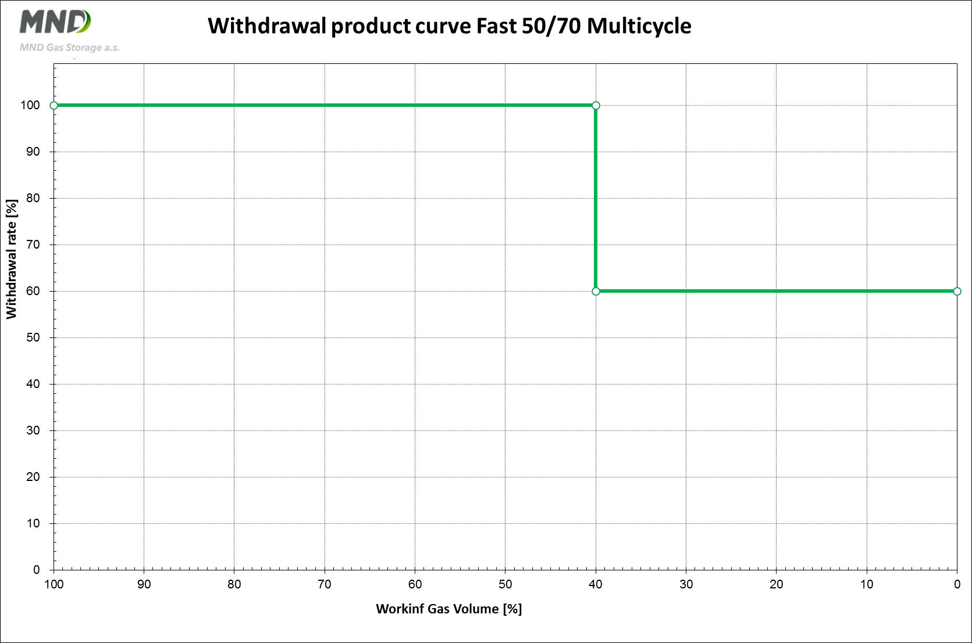
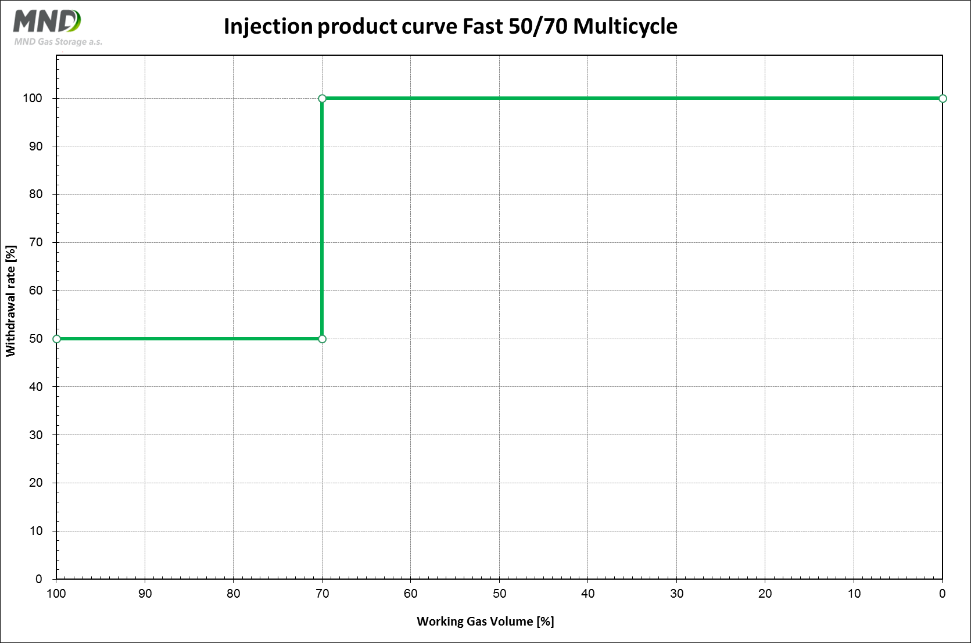
Annex No. 2 Agreement on the procedures for reservation of the short-term products
- The Storage User declares its intent to file electronic requests for the reservation of short-term storage products as defined in the Code (chapter I, article 2, letter. C, paragraph b)) (hereinafter as “request”).
- Based on the abovementioned intent, the Storage User and the Storage Operator agree that the Storage Operator shall make accessible online nomination portal to the Storage User so that the Storage User could file requests accordingly. The Storage Operator shall send the Storage User necessary access codes after the conclusion of this agreement.
- In case the Storage Provider is not able to ensure filing requests via the online nomination system due to the verifiable technical failure of such system or force majeure event, particularly by making data communication operator services inaccessible, the Storage Provider is entitled to determine an alternative way of electronic communication. In such a way the Storage User shall be immediately informed of such circumstance, together with information about the last registered request of the Storage User. For these cases the contracting parties stipulate that the Storage Provider is not responsible for potential damage.
- Availability and unit prices, alternatively minimum unit prices (concerning daily interruptible outputs), of respective short-term storage products are posted on the website of the Storage Operator. In the case the price changes, the price valid in the moment the request is made shall be deem decisive.
- By executing this agreement, the Storage User is obliged to follow the Market Rules, the Code, this agreement and model procedures published on Storage Operator’s webpages while filing a request (in case of conflicts or changes the hierarchy of the aforementioned shall be as follows: model procedure < this agreement < Code < Market Rules). In case the request is not following these rules, the Storage Operator is entitled to refuse such request without stating further reason and inform the Storage User of such refusal.
- Assessment of all requests filed by the Storage User or other entitled third parties that were not denied shall be induced by Storage Provider’s effort to utilise available capacities and outputs as economically as possible, considering technical possibilities of the storage facility known in the moment of assessment under the Market Rules.
- The result of the assessment is either approval or denial of the request. The result of the assessment shall be notified to the Storage User by means of electronic message.
- Electronic approval of the request shall establish a reservation of sought for product and at the moment of approval’s notification an individual storage contract is deemed to be concluded the content of which is determined by the content of such electronic approval, this agreement, the Code and the Market Rules.
- The electronic approval shall contain among others:
  - in case of the reservation of daily storage capacity with a firm output
    - duration of the individual storage contract (start and end day),
    - amount of reserved daily firm injection and/or withdrawal output and
    - the overall price for reserved service;
  - in case of the reservation of daily storage capacity with an interruptible output
    - duration of the individual storage contract (start and end day),
    - amount of reserved daily interruptible injection and/or withdrawal output and
    - minimum unit price valid at the moment of filing of request, or offered by the Storage User in its request (minimum or offered price shall be determinative in case the Storage Provider starts an interruption of outputs);
  - in case of the reservation of temporary daily storage
    - duration of the individual storage contract (start and end day),
    - amount of reserved storage capacity and
    - the overall price for reserved service.
- Payment conditions for individual storage contracts shall be governed by chapter III, article 10 of the Code. For price calculation regarding the storage capacity with interruptible output, only those output which were not interrupted are to be taken into consideration.
- Provisions of article VII and VIII of the main contract to store gas for reservation of annual storage capacity with fixed output, which this agreement is annex to, shall be also applicable to individual storage contracts.
- The contracting parties take into account, that in cases this annex is not executed by the signatures of party representatives, it shall not be binding upon any of the contracting parties and it shall not become part of the main contract, notwithstanding the fact it may be physically attached to such contract.
- This agreement is in effect for the whole storage period under the main agreement, i.e. from 1 April 2017, 6 a.m., until 1 April 2023, 6 a.m.

In Hodonín, date ………………………. In ……………………., date……………………..

On behalf of Storage Operator: On behalf of Storage User:

_______________________________ _______________________________
Ing. Karel Luner [●]
Chairman of the Board of Directors

_______________________________ _______________________________
Mgr. Slavomír Halla, Ph.D. [●]
Deputy Chairman of the Board of Directors

